Memorandum
To: Professor Cooperrider
From: DSK Engineering
Date: 4/1/2011
Re: Analysis after testing with LabView frequency graph
Introduction:
For this memo, we were tasked with getting our LabView program to correctly output data. From the collected data, we then applied a FFT (Fast Fourier Transform) to determine the maximum frequency for the case being tested. This process will be repeated several times on all of the cases presented in Dr. Penado’s paper, Stiffening an Off-Axis Beam Compressor Mount for Improved Performance.

Determining the Placement of Accelerometers:
Dr. Penado’s paper specifies the six cases that need to be verified. Each case includes a diagram showing what needs to be added or removed from the beam compressor such as the number of “feet” and supports. In addition, each case includes a computer-simulated picture depicting max displacement on the beam compressor. From these images, we were able to determine where to place our Endevco accelerometers and collect the max fundamental frequency of the beam compressor for each case. We did three trials of each maximum and minimum frequency to verify consistency and to acknowledge that we could interpret the images presented in the paper.

Experimental Analysis:
A LabVIEW VI, a signal conditioner, and a data acquisition system were used to collect the accelerometer data and output the acceleration and time associated with the incoming data into an Excel spreadsheet. The data was then plotted and the result is shown below in Figure 1.

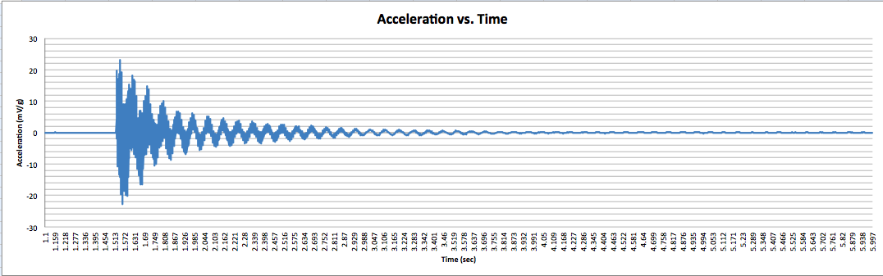
Figure 1: Acceleration vs. Time

Upon noting the high quality of the data and the lack of noise presented in the signal, the data was then placed into another spreadsheet in which a Fast Fourier Transform (FFT) function was run on the data. Figure 2 (below) shows the results of this FFT for Case 1.

Figure 2: FFT Frequency vs. FFT Magnitude

With the use of the FFT, the fundamental frequency was found to be equal to 12.98 Hz. The table below shows the fundamental frequency for the theoretical and experimental solutions and the relative error between them.

 | FEA Frequency (Hz) | Experimental Frequency (Hz) | Relative Error (%)
Vibrating System | 17.4 | 12.98 | 25.4

Table 1: Experimental Frequency vs. FEA Frequency

Conclusion:
As seen in the above results, we are well into our project and on the right path for success. We have completed testing and collected all of our frequency data. For our next deliverable, we will run the FFT for the other 5 cases and finish Table 1 with all 6 cases. The third deliverable will be submitted on April 17th.
Confidential

Attached is the spreadsheet containing the raw data with the FFT already completed on the spreadsheet through the use of a macro. If you have any questions or concerns please feel free to contact us.

